INTEGRATIVE COURSE IN PSYCHOLOGY (ICOPSYCH)

ANALYSIS ON THE RESULT OF PRE-TEST EXAMINATION IN ABNORMAL PSYCHOLOGY
MARCH 15, 2025

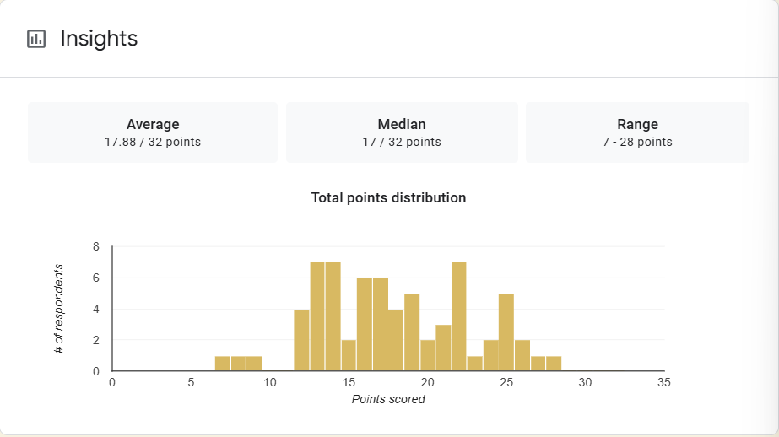

1. Mean Score: The mean score of 17.88 suggests that, on average, students scored just under 18 out of a possible 32 points. This indicates that the overall performance is moderately below the maximum score. While not extremely low, it suggests that there may be room for improvement across the board.

2. Median Score: The median score of 17 represents the middle value of the distribution, meaning that half of the students scored below 17 and half scored above 17. This score is very close to the mean, suggesting a relatively balanced distribution where most students are clustered around the mid-range of the scoring scale.

3. Range: The range of scores (7 to 28 points) indicates the spread between the lowest and highest scores. The wide range shows a notable variability in student performance. The lowest score (7 points) suggests some students struggled significantly, while the highest score (28 points) indicates that some performed quite well, although the maximum possible score is 32.

Interpretation Summary:

-Both the mean and median scores are close to 17, suggesting that the typical student performance is around the mid-point of the scoring scale.

-The range of 7 to 28 points shows a significant spread in student performance, with some students scoring at the lower end while others performed better.

-The overall performance is moderate, with many students clustering around the median, but there are both lower and higher-performing students in the group. This could suggest areas where some students might need additional support or instruction to improve their scores.

-In conclusion, while the exam results show some variability, the overall performance appears to be average, with a potential need for intervention or targeted teaching to address the students scoring lower in the range.

RATIONALIZATION:

DIFFICULT QUESTIONS:

